WEEK 3 TASK: ADVANCED DATA ANALYSIS AND VISUALIZATION IN LOGISTICS
Submitted By: Priya Rao
Internship: Logistic Data Analyst Intern
Task: Week 3 – Advanced Data Analysis and Visualization
Tools Used: Python, Pandas, NumPy, Matplotlib, Seaborn, Google Colab

1. INTRODUCTION
This report presents an advanced analysis of a hypothetical logistics dataset using Python. The main objective of this task was to explore logistics performance data, identify important patterns, analyze relationships between variables, and present the findings through meaningful visualizations.
The analysis focuses on important logistics factors such as delivery time, shipment volume, transportation cost, delivery distance, shipment weight, customer ratings, shipping mode, and delivery status.
Python libraries including Pandas, NumPy, Matplotlib, and Seaborn were used for data generation, exploratory data analysis, statistical calculations, and visualization. The analysis helps demonstrate how data-driven techniques can support logistics decision-making by identifying cost drivers, delivery patterns, operational differences, and possible areas for improvement.

2. OBJECTIVES
The main objectives of this analysis were:
- To create a hypothetical logistics dataset for analysis.
- To perform exploratory data analysis using Python.
- To calculate central tendency and descriptive statistics.
- To examine distributions of important logistics variables.
- To identify correlations between numerical variables.
- To compare logistics performance across different shipping modes.
- To analyze transportation cost and delivery-time patterns.
- To identify potential operational bottlenecks.
- To provide data-driven recommendations for improving logistics performance.

3. DATA SIMULATION
A hypothetical logistics dataset containing 500 orders and 9 variables was created using Python.
The dataset contains the following variables:
Variable | Description
Order_ID | Unique identification number for each order
Delivery_Days | Number of days required to deliver an order
Shipment_Volume | Volume of the shipment
Transportation_Cost | Cost associated with transportation
Distance_km | Distance covered for delivery
Shipment_Weight_kg | Weight of the shipment
Customer_Rating | Customer rating from 1 to 5
Shipping_Mode | Mode of transportation such as Road, Rail, Air, or Sea
Delivery_Status | Indicates whether delivery was On Time or Late
The dataset was generated using NumPy random functions and converted into a Pandas DataFrame.
Screenshot 1.
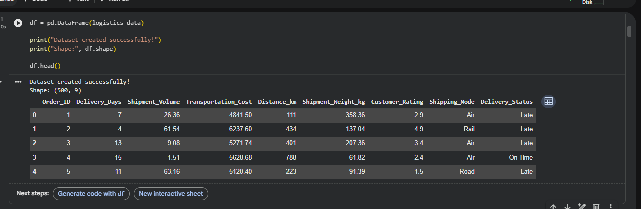
Figure 1: Sample of the simulated logistics dataset

4. EXPLORATORY DATA ANALYSIS
Exploratory Data Analysis (EDA) was performed to understand the structure and characteristics of the dataset.
The dataset contains 500 rows and 9 columns. The data types of the variables were checked, along with missing values and duplicate records.
The analysis also included descriptive statistics such as count, mean, standard deviation, minimum, maximum, and quartile values.
The dataset was checked for missing values and duplicate rows to ensure that the analysis was based on clean data.
Screenshot2.
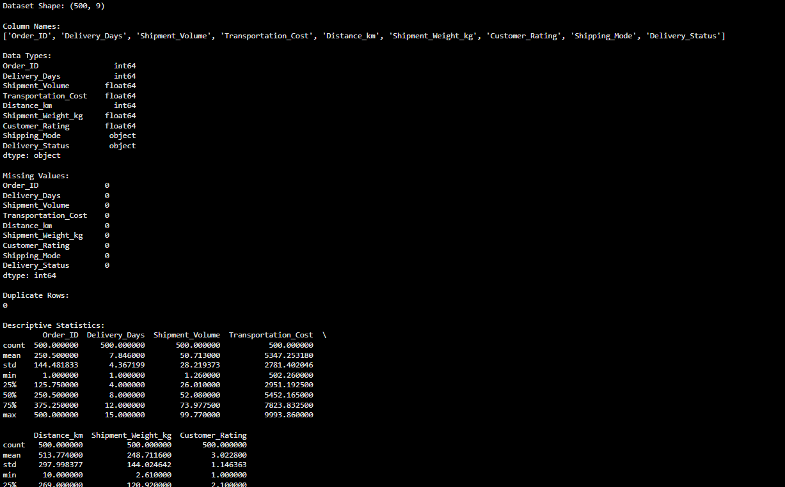
Figure 2: Descriptive statistics of numerical logistics variables

5. CENTRAL TENDENCY ANALYSIS
Mean, median, and standard deviation were calculated for important numerical variables including delivery days, shipment volume, transportation cost, distance, shipment weight, and customer rating.
The mean represents the average value, while the median represents the middle value of the observations. Standard deviation was used to understand the variation in the data.
These statistical measures provide a basic understanding of typical logistics performance and the variability between individual shipments.

6. VISUALIZATION AND ANALYSIS

6.1 Distribution of Delivery Days
A histogram was used to visualize the distribution of delivery days.
Screenshot 3.
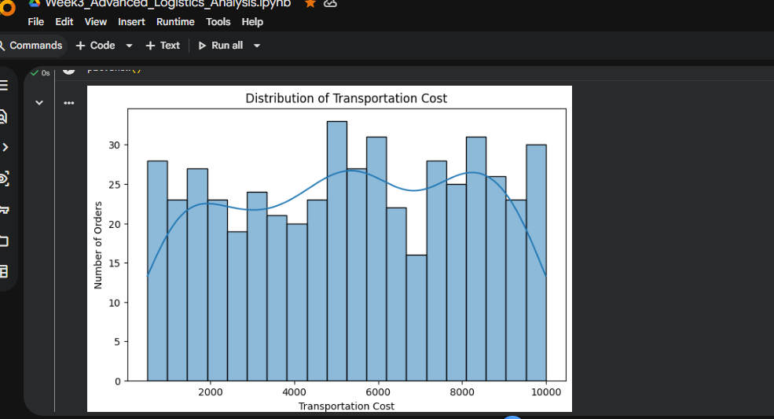
Figure 3: Distribution of delivery days

Interpretation
The delivery-days distribution shows how delivery times are spread across the orders. This visualization helps logistics teams understand the typical delivery duration and identify whether some shipments require considerably more time than others.
Understanding delivery-time variation is important because unusually long delivery times may indicate operational delays, inefficient routes, or other logistics bottlenecks.

6.2 Transportation Cost and Distance
A scatter plot was used to examine the relationship between transportation cost and delivery distance.
Screenshot 4.
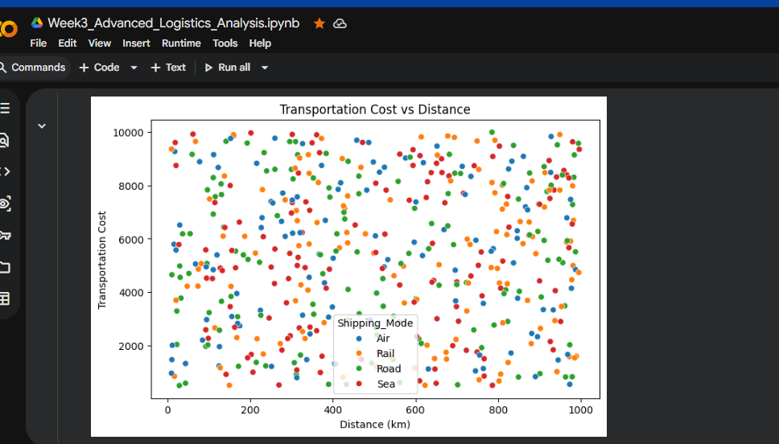
Figure 4: Transportation cost versus delivery distance

Interpretation
The scatter plot helps examine whether transportation costs increase as delivery distance increases. Distance is an important potential cost driver because longer routes generally require more transportation resources.
The visualization can therefore help logistics managers understand the relationship between route distance and transportation expenditure and identify unusually expensive shipments.

6.3 Shipping Mode Analysis
Different shipping modes were compared to 5understand their operational performance.
Screenshot5.
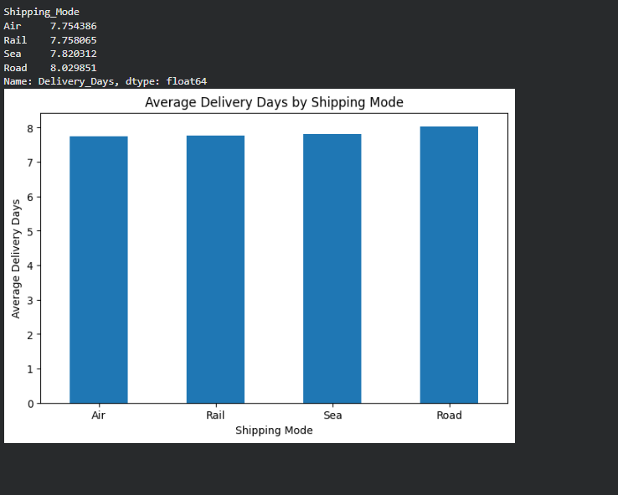
Figure 5: Logistics performance by shipping mode

Interpretation
The comparison of shipping modes helps identify differences in transportation cost and delivery time. Each transportation mode can have different operational characteristics.
For example, a mode with lower average delivery time may be useful when speed is the priority, while a lower-cost mode may be preferable for shipments where delivery urgency is lower.
This comparison can support better transportation-mode selection.

6.4 Delivery Status Analysis
The delivery-status distribution was analyzed to compare On Time and Late shipments.
Screenshot6.
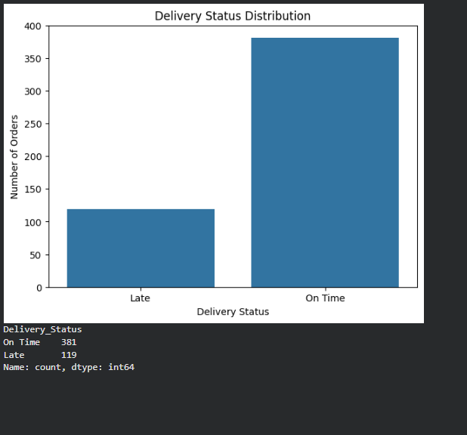
Figure 6: Delivery status distribution

Interpretation
The delivery-status visualization provides an overview of the proportion of orders delivered on time compared with late orders.
A high proportion of late deliveries may indicate potential issues in transportation planning, route selection, shipment handling, or delivery scheduling. Monitoring this metric regularly can help logistics teams improve service reliability.

7. CORRELATION ANALYSIS
Correlation analysis was performed to identify relationships between numerical logistics variables.
A correlation heatmap was used to make these relationships easier to understand.
Screensh.
Figure 7: Correlation heatmap

Interpretation
The correlation heatmap shows the strength and direction of relationships between numerical variables.
A positive correlation indicates that two variables tend to increase together, while a negative correlation indicates that one variable tends to decrease when the other increases.
The heatmap can help identify potential relationships between delivery time, transportation cost, distance, shipment weight, shipment volume, and customer rating.
Correlation does not necessarily mean that one variable causes another, but it provides useful information for further logistics investigation.

8. KEY LOGISTICS PERFORMANCE INDICATORS
The following key performance indicators were calculated:
- Total number of orders
- Average delivery time
- Average transportation cost
- Average delivery distance
- Number of late orders
- Late delivery rate
These KPIs provide a concise overview of overall logistics performance.
The KPI analysis can help management monitor operational efficiency and identify areas that require improvement.

9. KEY ANALYTICAL INSIGHTS
Based on the analysis and visualizations, the following insights were identified:
- Delivery time varies across shipments, making delivery-time monitoring important for maintaining service quality.
- Transportation cost should be analyzed together with delivery distance because longer routes can require greater transportation resources.
- Shipping modes show different operational characteristics in terms of cost and delivery time. Therefore, transportation mode should be selected according to shipment requirements.
- Late deliveries represent an important operational metric. Monitoring late-delivery rates can help identify potential bottlenecks.
- Correlation analysis provides useful information about relationships among logistics variables and can support further investigation.
- Combining KPIs with visual analysis provides a clearer understanding of logistics performance than examining individual variables separately.

10. POTENTIAL BOTTLENECKS
The analysis suggests several areas that logistics managers should monitor:
- Long delivery durations
- High transportation costs
- Long-distance shipments
- Higher frequency of late deliveries
- Inefficient selection of shipping modes
- Shipments with unusually high transportation costs
These areas can be investigated further using detailed route-level, supplier-level, or transportation-level data.

11. RECOMMENDATIONS
Based on the analysis, the following recommendations can be made:

1. Optimize Transportation Routes
Analyze long-distance routes regularly and identify opportunities to reduce unnecessary travel distance and transportation costs.

2. Select Shipping Modes Strategically
Shipping modes should be selected according to delivery urgency, shipment characteristics, distance, and cost.

3. Monitor Late Deliveries
The late-delivery rate should be tracked regularly. Orders with unusually long delivery times should be investigated to identify the underlying causes.

4. Monitor Transportation Costs
High-cost shipments should be reviewed to determine whether the cost is justified by distance, shipment weight, volume, or transportation mode.

5. Use Data-Driven KPIs
Logistics teams should regularly monitor delivery time, transportation cost, late-delivery rate, and shipment volume to support data-driven decisions.

12. TOOLS AND TECHNOLOGIES USED
The following tools and Python libraries were used:
- Google Colab – Development and execution environment
- Python – Data analysis programming language
- Pandas – Data manipulation and analysis
- NumPy – Numerical calculations and data simulation
- Matplotlib – Data visualization
- Seaborn – Statistical visualization and correlation analysis

13. CONCLUSION
This project demonstrated how Python can be used to perform advanced logistics data analysis and visualization. A hypothetical logistics dataset was created and analyzed using statistical techniques and visualizations.
The analysis examined delivery times, transportation costs, distance, shipment characteristics, shipping modes, and delivery status. Different visualization techniques helped identify patterns and relationships that may not be easily understood from raw data alone.
The results demonstrate the importance of exploratory data analysis and visualization in logistics decision-making. By monitoring key performance indicators and investigating cost and delivery patterns, organizations can identify operational bottlenecks, improve transportation planning, reduce unnecessary costs, and improve delivery reliability.
Overall, this task improved practical understanding of Python-based data analysis and demonstrated how analytical insights can support more effective and data-driven logistics operations.

14. PYTHON CODE USED
The analysis was performed using Python with Pandas, NumPy, Matplotlib, and Seaborn. The main techniques used included:
- Dataset generation using NumPy
- DataFrame creation using Pandas
- Descriptive statistics using describe()
- Mean and median calculations
- Group-by analysis
- Correlation analysis
- Histograms
- Bar charts
- Scatter plots
- Heatmaps
The complete Python notebook contains the code used to generate the dataset, perform the analysis, and create the visualizations.

